**Assignment Javascript 3 ( 06/01/2022)**

**P1:- Find if given substring is in string**

var str = "aakash rawal";

var inputStr = "rawal"

if (str.includes(inputStr)) {

console.log(inputStr, "search found");

} else {

console.log(inputStr, "not found");

}

Output: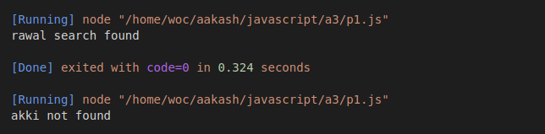

**P2:- Print all the elements of the array**

const arrCars = ["BMW", "Volvo", "Saab", "Ford", "Fiat", "Audi"];

var txt = " ";

for (var i = 0; i < arrCars.length; i++) {

console.log(arrCars[i]);

}

Output:

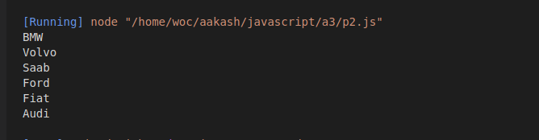

**P3:- Create 2D array of array and print all the element with it’s indexes**

var arr2D = [

[1, 5, 3],

[56, 43, 65],

[7, 8, 3, ]

];

for (let i = 0; i < 3; i++) {

for (let j = 0; j < 3; j++) {

console.log("Value: ", arr2D[i][j], "index: ", i, j);

}

console.log("=======================");

}

Output

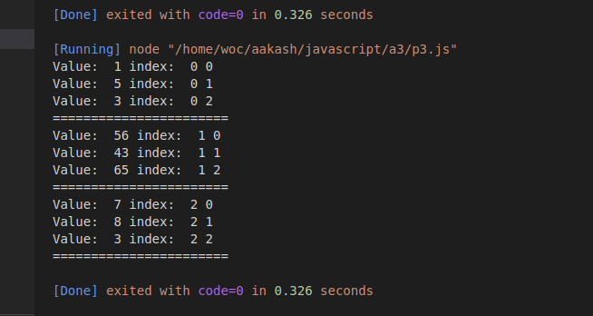

**P4:- Do multiplication elements of two array with same length and create 3rd array**

var arr1 = [2, 4, 3, 6];

var arr2 = [5, 3, 7, 3];

var arrMul = [];

for (let i = 0; i < arr1.length; i++) {

for (let j = 0; j < arr2.length; j++) {

arrMul[i] = arr1[i] * arr2[i];

}

}

console.log(arrMul);

Output:

